Exam 1 MAST418.618 2021 Name: ____________________________________

Expected answer lengths are in parentheses after each question.

- In the Roller et al. 2016 paper, this graph of protein yield or translational power vs ribosomal copy number was used to help explain how ribosomal genes are representative of microbial growth strategy. (answer: labels and 1 paragraph)
10 pts
- Label where a copiotroph and an oligotroph would be on the top graph (make sure to distinguish which is which).
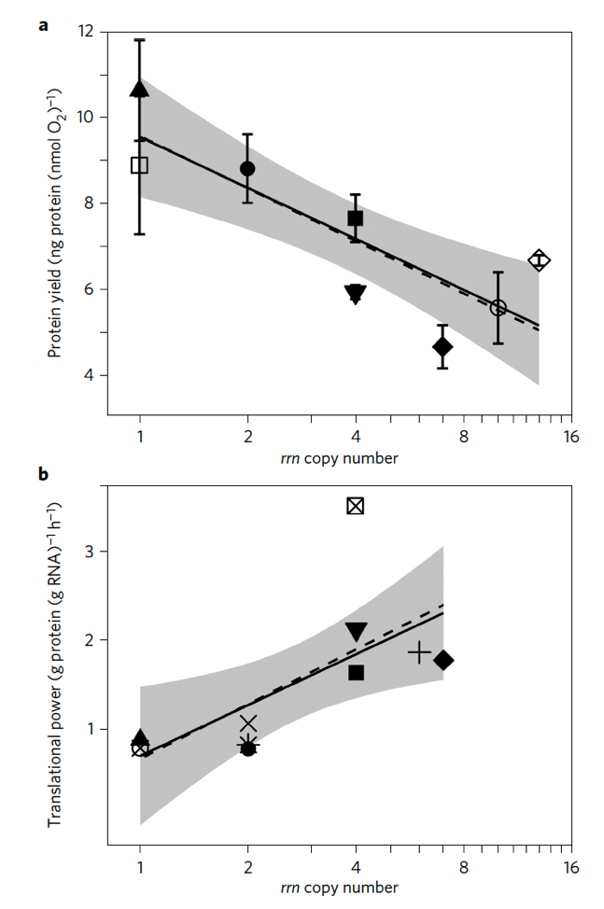
oligotroph

copiotroph

B). What explains how organisms with 1 copy of a ribosomal operon (rrn) make more protein per O₂ than one with 10 copies?
Bacteria have the ability to grow fast or even slowly based on the optimal conditions for such growth. Organisms with 1 rrn copy will make more protein per O₂ than one with 10 copies because of some conditions. Under such a scenario it means that there is insufficient carbon and this will happen to oligotroph since is very common in areas with few resources. With 10 rrn copy only copiotrophs will survive because they need a lot of resources which is available due to increase in number of rrn copy. Hence organisms with 1 rrn copy will produce more proteins than those with 10 rrn copy.

- Arrange these organisms from smallest to largest: zooplankton, viruses, protists, bacteria (1 line)
5 pts
Virus, bacteria, zooplankton, protists
- What is the “great plate count anomaly” and how has it impacted microbiology? (~2 paragraphs)
10 pts

The great plate count anomaly is viewed as an observation that shows how many of microbes, we see in a microscope it is impossible to use laboratory conditions to support their growth. This is because some of these microbes viable while other not viable.
The great plate count anomaly has impacted microbiology positively in that microbiologists have applied it by food production and shown no significant problem. For instance, it is being applied in agar in culturing microbes from the surrounding. Nutrients are also changed in media and parameters like pH and temperature in promotion of certain microbes.
10 pts
- What are some reasons that genome sizes vary between bacteria and eukaryotes? (max 3 paragraphs)
One of the reasons is that genome size will vary a due to differences in the amplification, deletion, and divergence of various repetitive sequences, and also the transposable elements. This constitutes a to large proportion of the genome.
In eukaryotic, genome sizes enormously vary. The variation is however not related to intuitive ideas of complexity morphology. In eukaryotes, there is non-coding of major nuclear DNA. Eukaryotes are diploid and the DNA is always organized into many linear chromosomes. These chromosomes are found in nucleus of their cell. Eukaryotes also archaea and they make use of histone proteins, besides bacteria and this brings about variation (Wilhelm and Hahn, 2004).

- Give an example of a fermented food that is a combination of both bacterial and eukaryotic fermentation. Explain briefly how that fermentation occurs in the food and what cycle of the food preparation it occurs in. (max 3 paragraphs)
10 pts

Yoghurt is a food that produced by combination of bacterial and eukaryotic fermentation. This is because, in its preparation both oxygen and bacteria are involved.
This formation occurs when bacteria interact positively with the Milk. Two bacteria streptococcus thermophilus and Lactobacillus delbrueckii ssp. bulgaricus. The first bacteria grow first in milk since there is adequate oxygen conditions that allows development of L. bulgaricus. The L. bulgaricus then breaks milk (Protein) into amino acid easing collection of nutrients by S. thermophilus as it grows.
The tow bacteria hence continue straining in transforming milk’s lactose into acid. Casein contained in milk clump forming thick substance called yogurt. Lastly temperatures are lowered to lower acidity of yogurt.
2 pts
- Silica is important for which type of microbial cell? (1 sentence)
Silica is important in bacterial cells like Bacillus subtilis

- What is a limiting nutrient for bacteria in the surface ocean in the middle of the Atlantic Ocean? (1 sentence)
2 pts
The limiting nutrient for bacteria in the surface ocean in the middle of the Atlantic Ocean is nitrogen.
- Explain how cells can maintain their osmotic balance in the ocean. (1 paragraph).
6 pts
The cells in saline waters under go what we call osmoregulation whereby the amount of water as well as salt is held constantly based on the changes with the environment. Therefore, the cells are able to have equal intake as well as outflow both salts and water for a certain period of time. These cells maintain internal osmolarity that is totally different form the surrounding they are immersed in. They then control their osmolarity to maintain and keep internal conditions constant. So ideally the cell tends to loss water, and this water moves to hypertonic or “high salt” environment. When there is an equal salt concentration in both cells and oceanic salt environment then osmotic pressure is equalized hence osmotic balance (Molnar & Gair, 2021).
15 pts
- What is an advantage of motility in the ocean for a microbe? What is a disadvantage? What is an alternative lifestyle? (max 3 paragraphs)
One of the advantages is that, motility enables microbes to potentially acquire nutrients. The mobility is also useful for the microbes to substances that are toxic substances. Besides it offers an organism ability to translocate. This is where microbes move to preferred hosts and access optimal colonization sites within them, and dispersal in the environment during the course of transmission. The cell mobility involving microbes comes with a benefit that allows cells to acquire resources even if the environment is more competitive.
However, the disadvantage is that it increases metabolic burden especially for those flagella undergoing synthesis. The competition for resources might exhaust the host and when this happens microbe’s population would reduce due to nutritional strains.
An alternative lifestyle for microbes adopting vivo strategy during their life cycles. This strategy helps them in activating virulence gene program making them to form a surface that is multicellular and get attached to the organism. This enables it to respond and survive in different environments.

- What is a characteristic of microbial communities regarding their diversity and evenness? (max 3 paragraphs)
10 pts
Microbial communities are characterized by the fact that, microorganisms in this communities share universal living environment. The microorganism in this group exhibit high degree of genetic and phenotypic similarity.
Their structural composition and abundance of species. They also occupy a physical location with individual of same species forming a population.
They have functional diversity that shows the link between their functioning ecosystem and its biodiversity patterns. Such diversity implies the way such organisms interact within their environment. The species are evenness to biodiversity which gives a clear indication on how their ecosystem is stable.
2 pts
- What is an OTU? (1 sentence)

An operational taxonomic unit for categorizing bacteria by considering similarity of their sequence.
2 pts
- Name 2 different ways that you can obtain an organism’s genome. (max 2 paragraphs)
One way of obtaining an organism’s genome is through high-throughput done by carrying out single cell isolation. This is done preserving and pretreating a couple environmental samples and then conduct physical separation for amplification of whole genome.
The second way is obtaining Organelle genome through amplification of chromosome within the organelle. This method is involves acquiring partial or complete sequence of an organelle genome.
5 pts
- Describe a scenario where a cell may have an apparent concentration of DNA that is higher than what is expected based on its genome. (1 paragraph)
This will occur in a situation where DNA amount contained in its haploid genome has less kilobases like 1kb and also evolution and mutation of such genome. In case of evolution of genome deletion or insertion may occur and the brings about some changes including changing of DNA concentration in its genome.
- Of the following: water, pH, temperature – which creates the greatest stress for microbial life? (max 3 paragraphs)
10 pts
While water, temperature and pH levels affect microbial life, water and more specific dampness affects microbial life. In essence, water is needed for fungi growth. Basically, water necessary for the microbes to thrive including all other living things.
Without water, the microbes are strained in that they cannot even grow. Even if they grow, they won’t multiply as required. Lack of water or moisture means that they would grow in buildings in presence of some warmth.
In places such basements as well as bathrooms we are likely to find some microbes due to dumpy conditions brought about by water in those areas. In case they dry up the microbes might not survive and thus water can strain microbial life.
1 pt
- Name a fermented food not yet mentioned in this exam. (1 sentence)
sourdough bread produced by fermenting dough.

References
Wilhelm J., Hahn M. (2004) Measuring Genome Sizes by Absolute Quantification. In: Wittwer C., Hahn M., Kaul K. (eds) Rapid Cycle Real-Time PCR — Methods and Applications. Springer, Berlin, Heidelberg. https://doi.org/10.1007/978-3-642-18840-4_4
Molnar, C. & Gair, J., (2021). 22.1. Osmoregulation and Osmotic Balance. [online] Opentextbc.ca. Available at: <https://opentextbc.ca/biology/chapter/22-1-osmoregulation-and-osmotic-balance/> [Accessed 21 March 2021].

